LAB SETUP REPORT
Foundation & Environment Setup
Practical Cybersecurity Laboratory
Attacker Machine: Kali Linux
Target Machine: Metasploitable2 / DVWA
Virtualization Platform: VMware
Network: NAT + Host-only
Prepared for academic practical work

Table of Contents

1. Introduction and Objective
2. Cybersecurity Basics
3. Lab Environment Setup
4. Linux Fundamentals
5. Networking Basics
6. Cryptography Basics
7. Tool Familiarization
8. Observations and Results
9. Conclusion
10. References

Introduction and Objective

This project establishes a controlled cybersecurity laboratory for learning cybersecurity, networking, Linux administration, cryptography, and security-tool fundamentals. Kali Linux is used as the security-testing workstation, while Metasploitable2 and DVWA provide intentionally vulnerable targets for authorized practice.

Objective

To build strong fundamentals in cybersecurity, networking, cryptography, and practical security testing by creating an isolated virtual lab and completing basic hands-on exercises.
- Understand the CIA Triad, common threat types, and attack vectors.
- Configure a private virtual lab using VMware, Kali Linux, and Metasploitable2/DVWA.
- Practice Linux filesystem navigation, permissions, package management, and networking commands.
- Study OSI/TCP-IP, DNS, HTTP/HTTPS, IP addressing, subnetting, and NAT.
- Perform basic encryption, decryption, hashing, certificate, and TLS exercises with OpenSSL.
- Become familiar with Nmap, Wireshark, Burp Suite, and Netcat.

2. Cybersecurity Basics

2.1 CIA Triad

Principle | Meaning | Example
Confidentiality | Only authorized users can access information. | Passwords, access control, encryption
Integrity | Information remains accurate and is not modified without authorization. | Hashing, digital signatures
Availability | Systems and information remain accessible when needed. | Backups, redundancy, DDoS protection

2.2 Threat Types

Threat | Description
Phishing | Fraudulent messages or websites intended to trick users into revealing information.
Malware | Malicious software such as viruses, worms, trojans, and spyware.
DDoS | An attack intended to make a service unavailable by overwhelming it with traffic or requests.
SQL Injection | Malicious input that interferes with an application's database query.
Brute Force | Repeatedly trying credentials until a valid password is found.
Ransomware | Malware that blocks access to data, commonly by encrypting files and demanding payment.

2.3 Attack Vectors

Social Engineering: Manipulating people into revealing information or performing unsafe actions.
Wireless Attacks: Attacks targeting wireless communication, authentication, or configuration.
Insider Threats: Intentional or accidental misuse of legitimate access by an authorized user.

3. Lab Environment Setup

The lab was configured in VMware using Kali Linux as the attacker/security workstation and Metasploitable2 as the vulnerable target. Kali was configured with NAT for Internet connectivity and a Host-only interface for the isolated target network. Metasploitable2 was connected to the Host-only network.

3.1 Virtual Machine Network Configuration

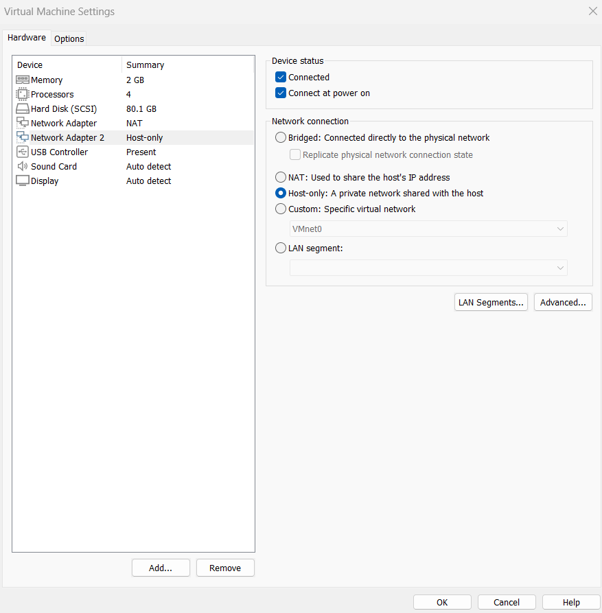
Figure 1. Kali Linux Host-only adapter configuration.
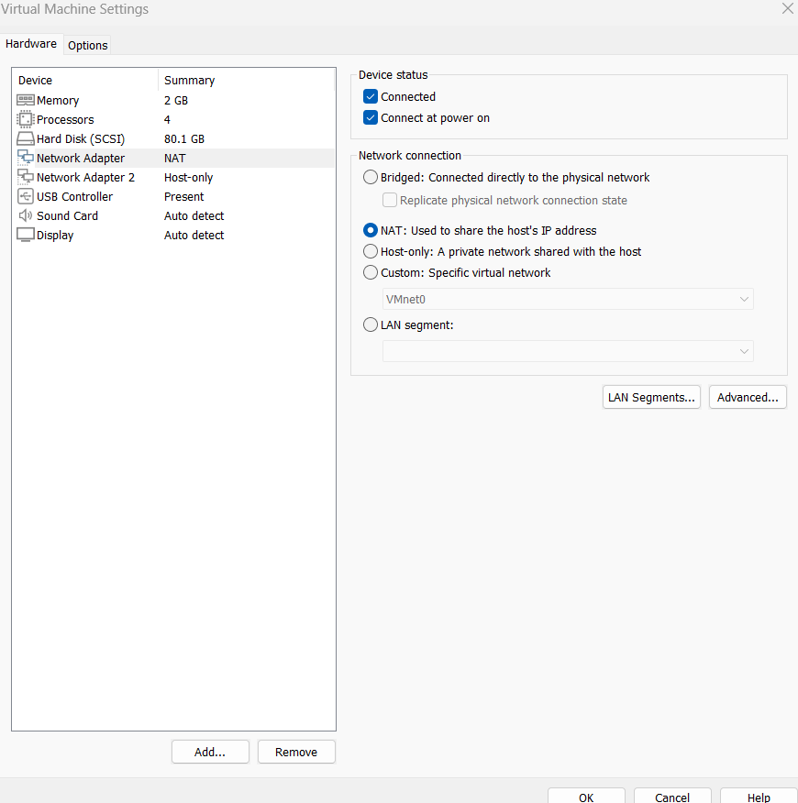
Figure 2. Kali Linux NAT adapter configuration.
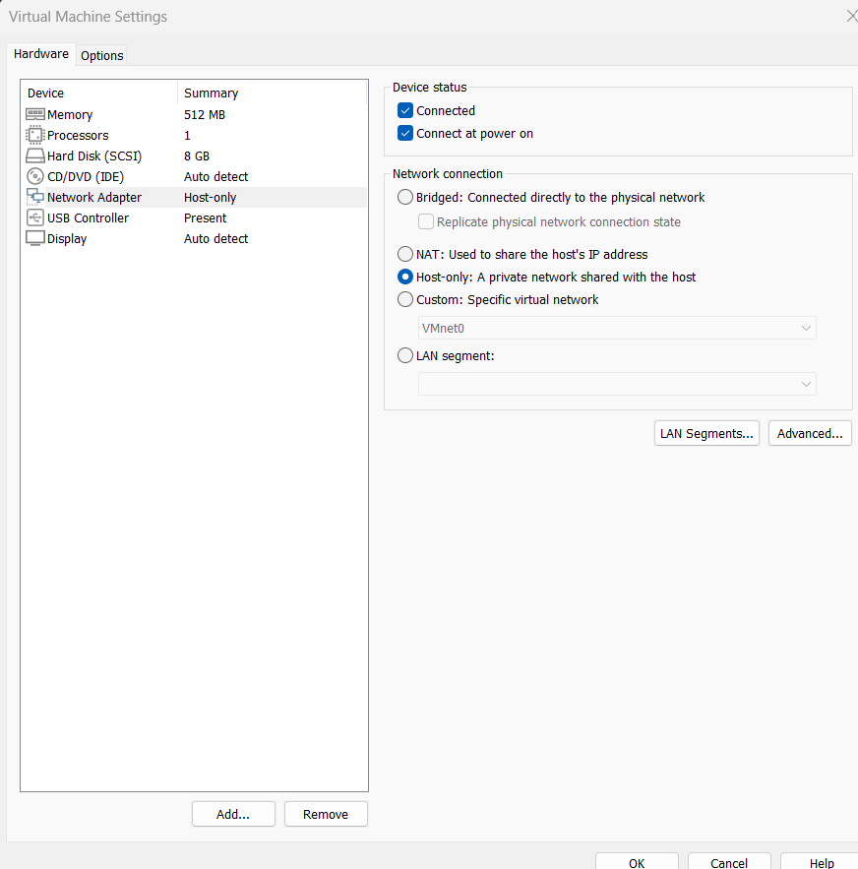
Figure 3. Metasploitable2 Host-only adapter configuration.

3.2 IP Configuration and Connectivity

The lab used the 192.168.133.0/24 Host-only subnet. Kali used 192.168.133.129 on its Host-only interface and Metasploitable2 used 192.168.133.128. A ping test verified communication between the two machines.
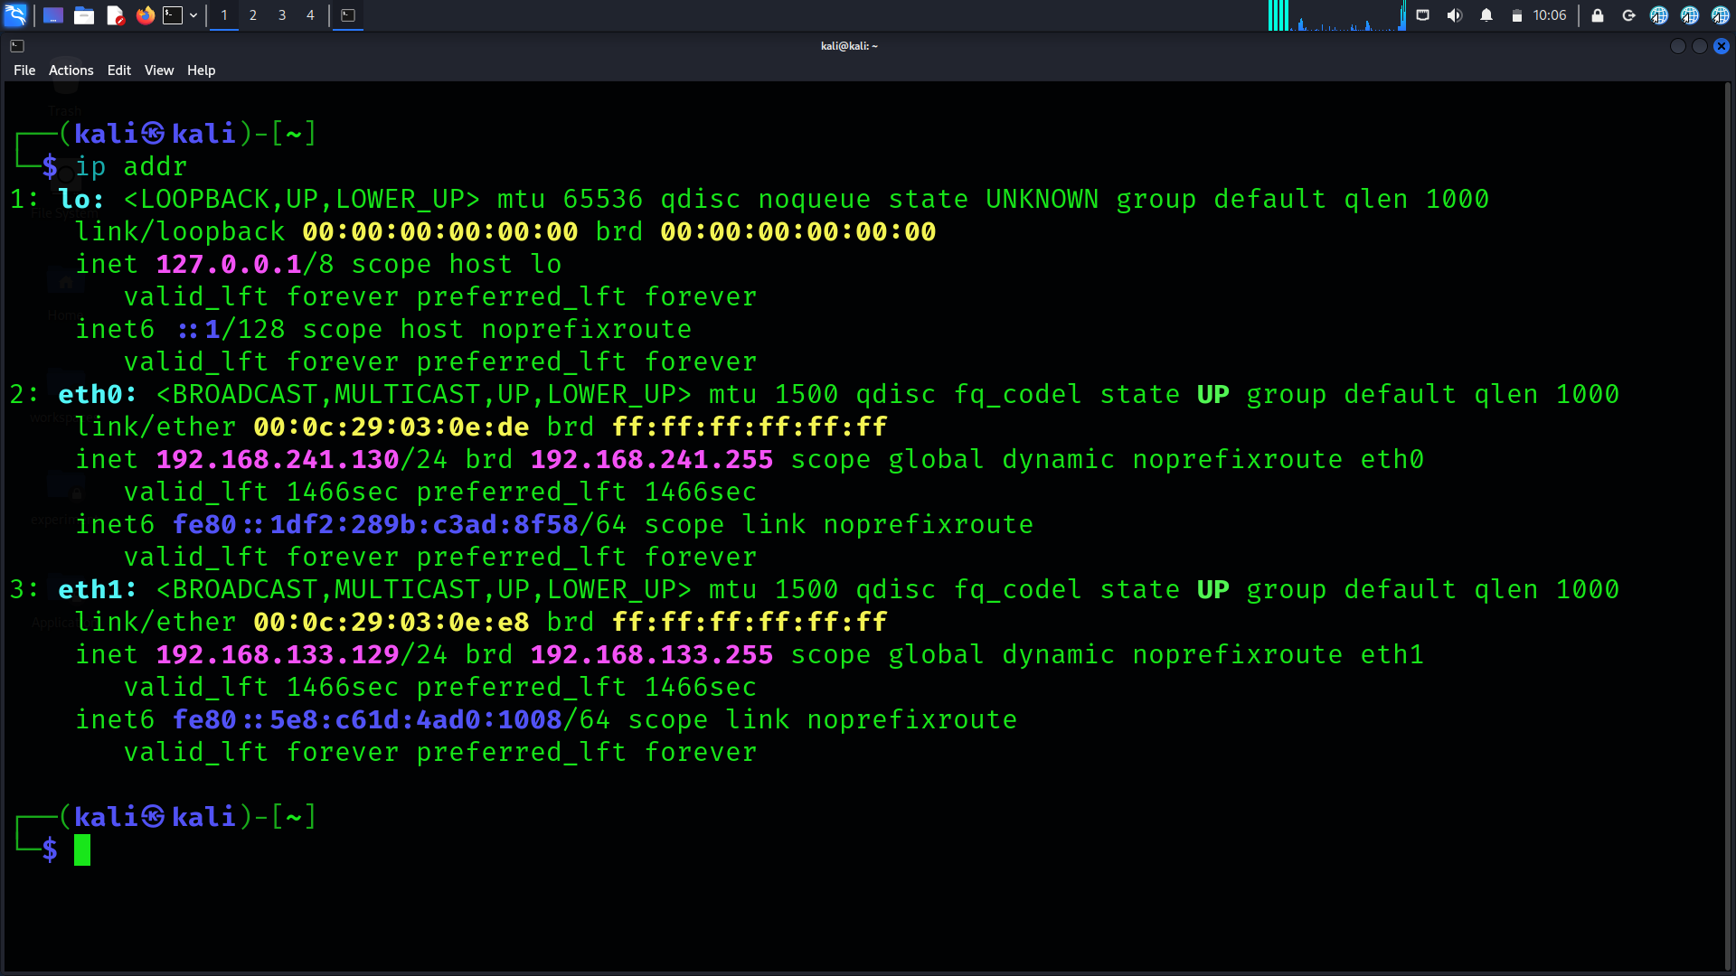
Figure 4. Kali Linux IP configuration.
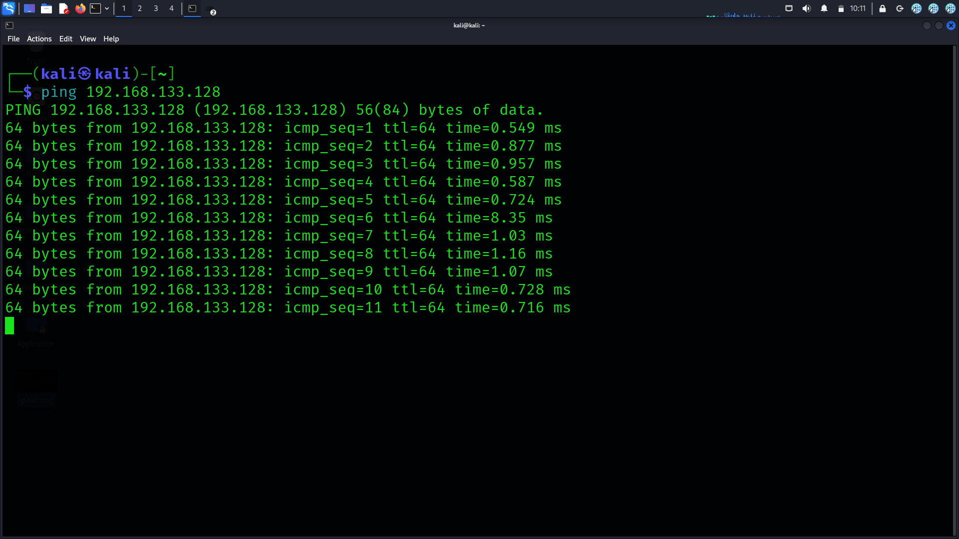
Figure 5. Connectivity test between Kali Linux and Metasploitable2.

3.3 Web Application Target

DVWA (Damn Vulnerable Web Application) was installed and accessible through the local web server. The application provides intentionally vulnerable modules for controlled web-security learning.
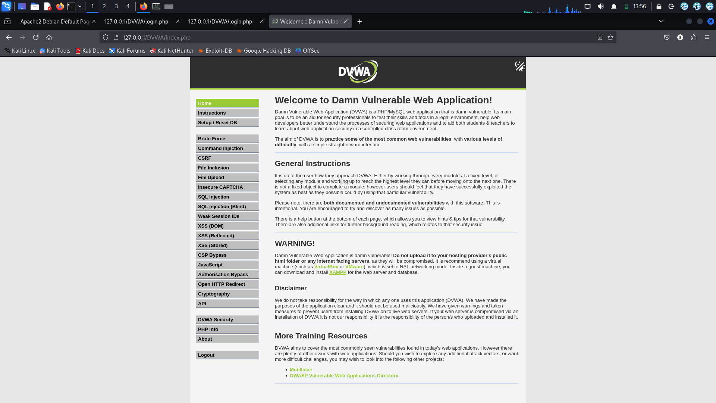
Figure 6. DVWA dashboard successfully loaded.

4. Linux Fundamentals

4.1 File System Navigation

The commands pwd, ls, and cd were practiced to identify the current working directory, list files, and navigate between directories.
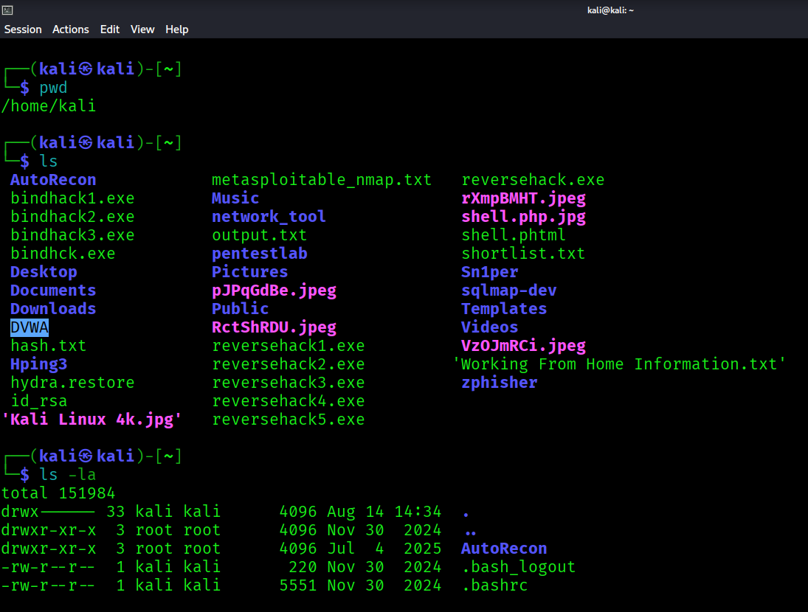
Figure 7. Linux filesystem navigation.

4.2 File and Directory Permissions

Linux permissions were examined and modified using commands such as chmod and chown. The exercise demonstrated ownership and read/write/execute permission concepts.
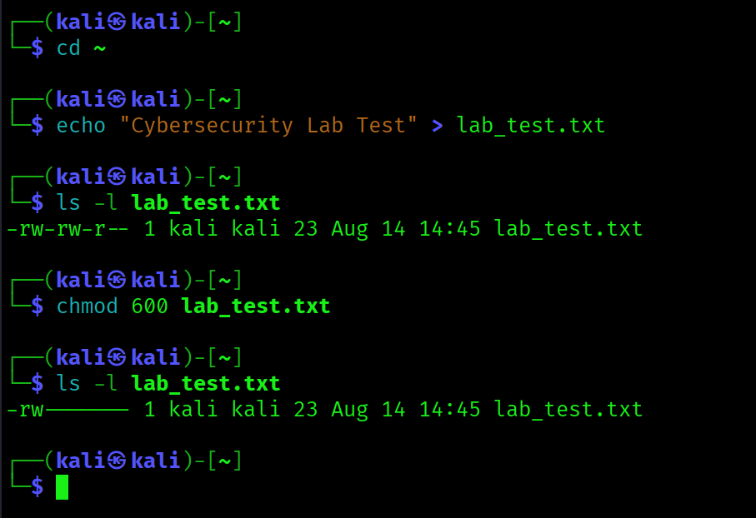
Figure 8. Linux file permissions and ownership.

4.3 Package Management

APT and dpkg were used for package installation, updates, and package configuration in Kali Linux.
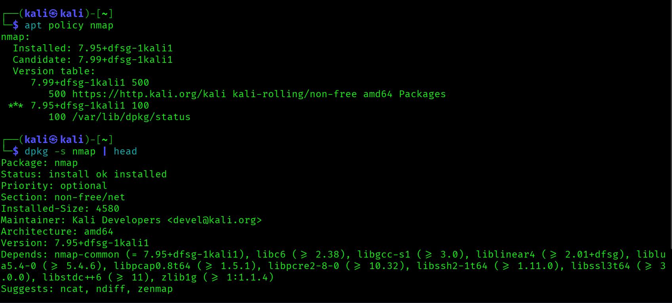
Figure 9. Package management using apt/dpkg.

4.4 Networking Commands

Commands such as ip/ifconfig, ping, netstat/ss, and traceroute were practiced to inspect interfaces, connectivity, routes, and listening services.
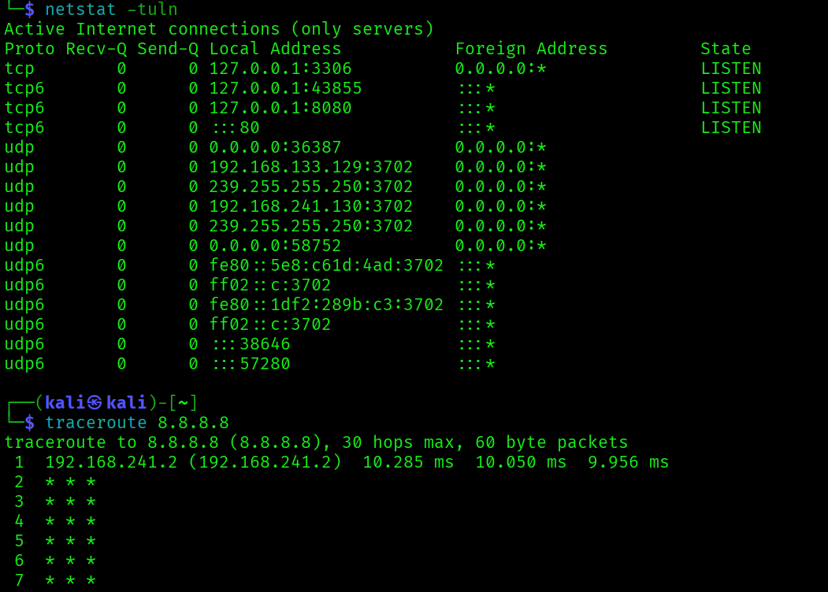
Figure 10. Linux networking commands.

5. Networking Basics

5.1 OSI Model

Layer | Name | Main Function | Examples
7 | Application | Provides services to applications | HTTP, DNS
6 | Presentation | Data representation, encoding, encryption | TLS, encoding
5 | Session | Establishes and manages sessions | Session control
4 | Transport | End-to-end delivery and ports | TCP, UDP
3 | Network | Logical addressing and routing | IPv4, ICMP
2 | Data Link | Local frame delivery | Ethernet, ARP
1 | Physical | Transmits raw bits | Cable, radio

5.2 TCP/IP Protocol Suite

Layer | Function | Examples
Application | Network services for applications | HTTP, DNS, FTP
Transport | End-to-end communication and port delivery | TCP, UDP
Internet | Addressing and routing | IPv4, ICMP
Network Access | Local network delivery | Ethernet, ARP

5.3 IP Addressing, Subnetting and NAT

The Host-only network uses 192.168.133.0/24 with subnet mask 255.255.255.0. The usable host range is 192.168.133.1–192.168.133.254 and the broadcast address is 192.168.133.255. Kali's NAT interface provides a separate path for Internet access.
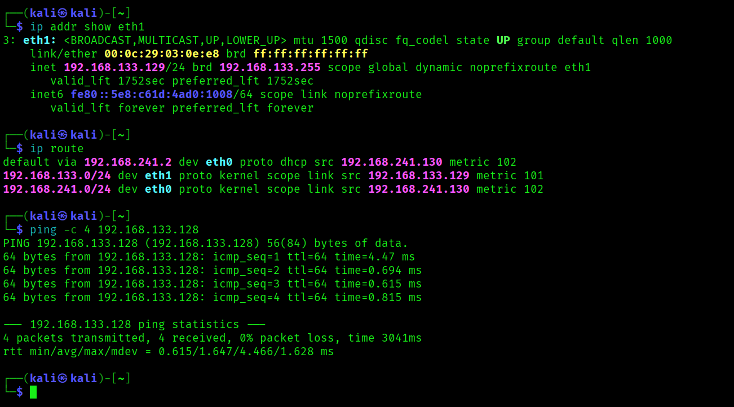
Figure 11. IP addressing and routing information.

5.4 DNS

DNS converts domain names into IP addresses. The lab verified resolver configuration and domain resolution using command-line tools.
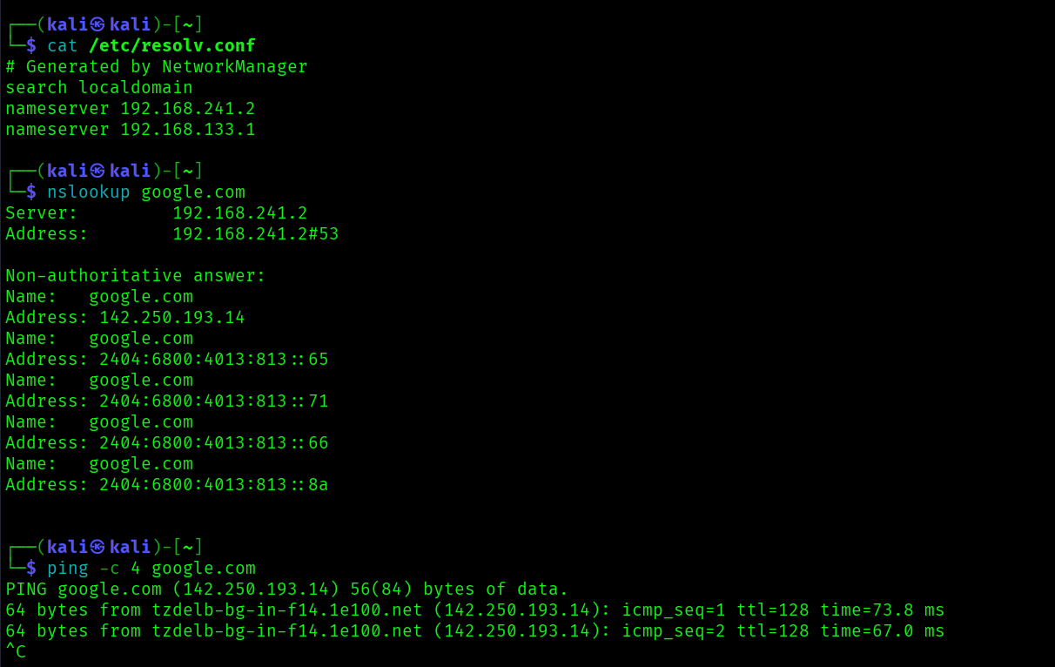
Figure 12. DNS practical test.
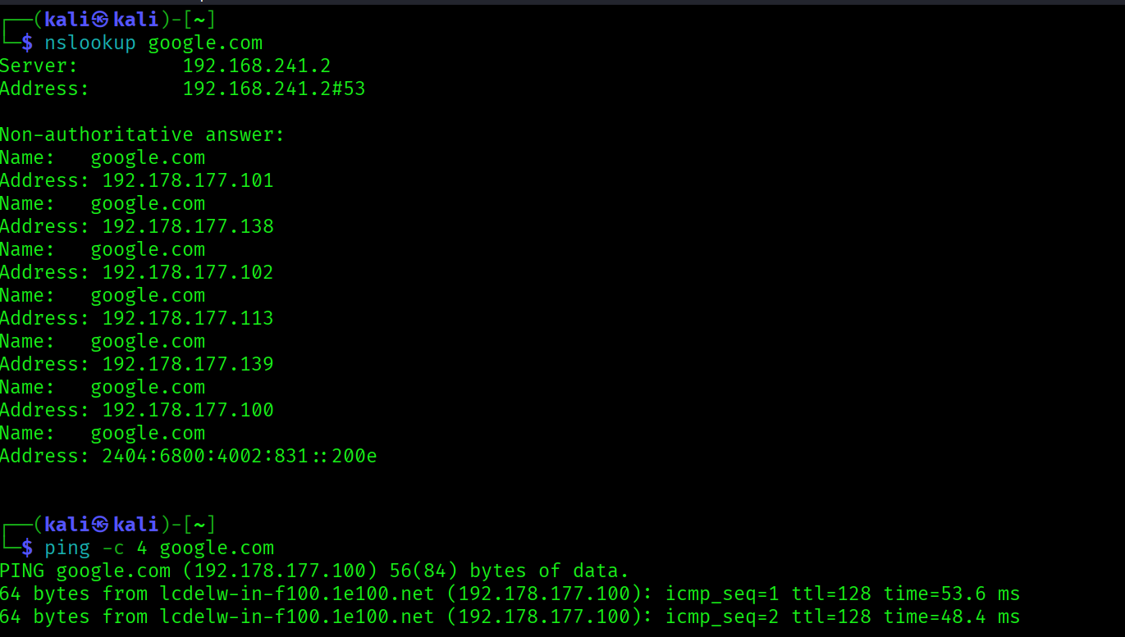
Figure 13. DNS resolution output.

5.5 HTTP/HTTPS

HTTP connectivity to the target web server was tested with curl. The practical work also distinguished HTTP from HTTPS and examined TLS-related behavior.
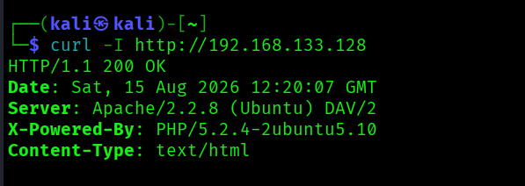
Figure 14. HTTP practical test.
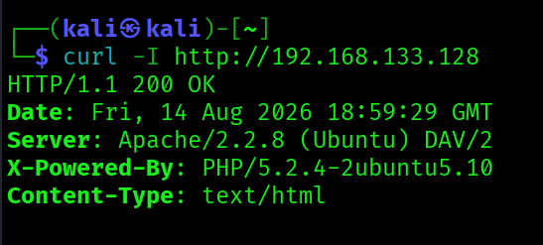
Figure 15. HTTP response from the target web server.

6. Cryptography Basics

6.1 Symmetric vs Asymmetric Encryption

Feature | Symmetric | Asymmetric
Keys | One shared secret key | Public/private key pair
Speed | Generally faster | Generally slower
Examples | AES | RSA, ECC
Typical use | Bulk data encryption | Key exchange, authentication, digital signatures

6.2 OpenSSL Encryption and Decryption

A test file/message was encrypted with OpenSSL using AES and then decrypted. The exercise demonstrated that the original content can be recovered when the correct decryption key/password is available.
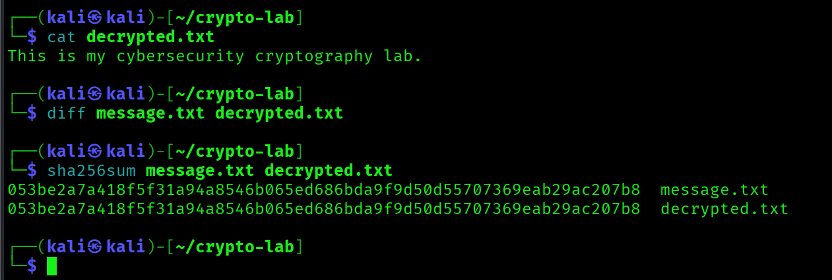
Figure 16. OpenSSL decryption operation and recovered content.
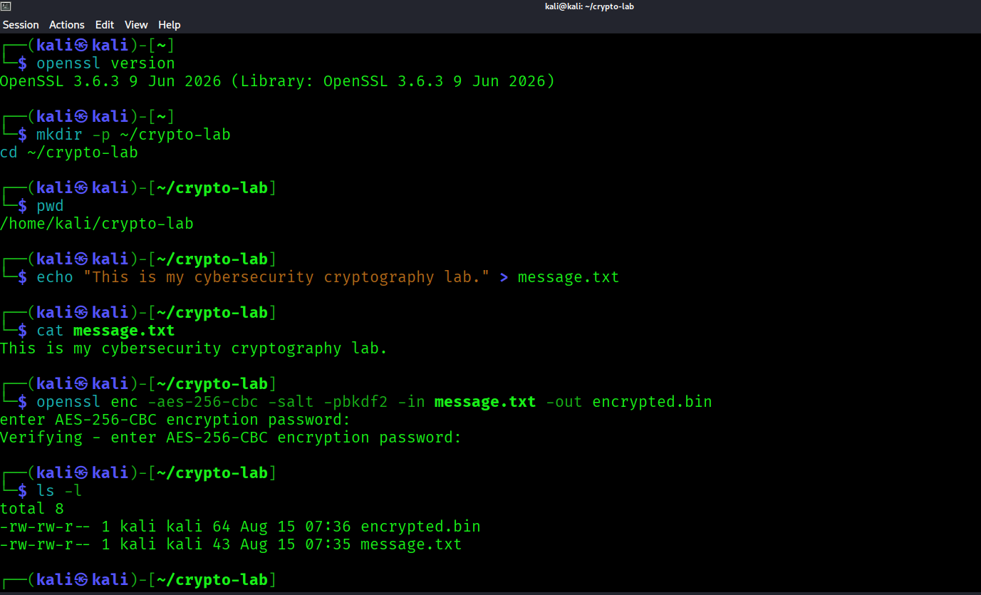
Figure 17. Additional cryptography/OpenSSL practical evidence.

6.3 Hashing

MD5 and SHA-256 hashes were calculated. Hashing is one-way and is primarily used for integrity verification rather than reversible encryption.
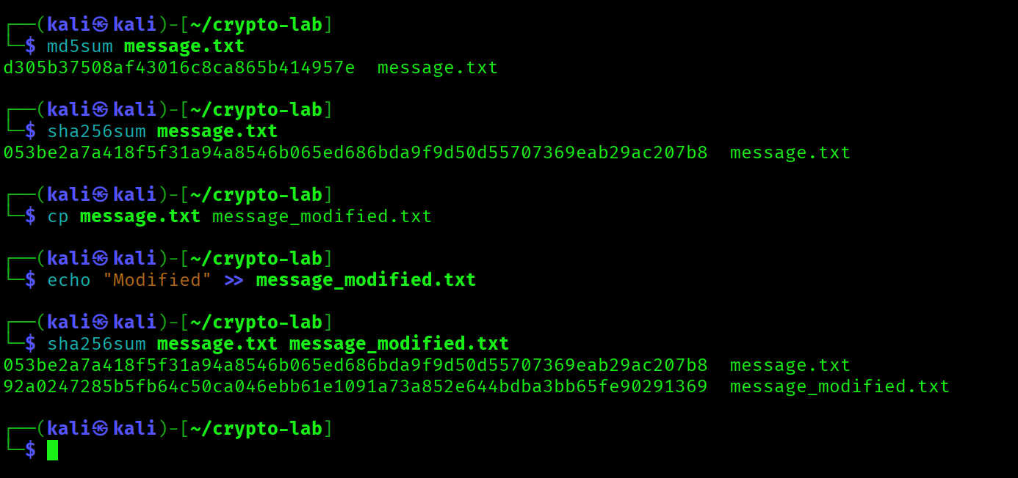
Figure 18. MD5 and SHA-256 hashing practical.

6.4 Digital Certificates

A 2048-bit RSA key and an X.509 certificate were generated with OpenSSL. Certificate fields such as subject, issuer, and validity were inspected.
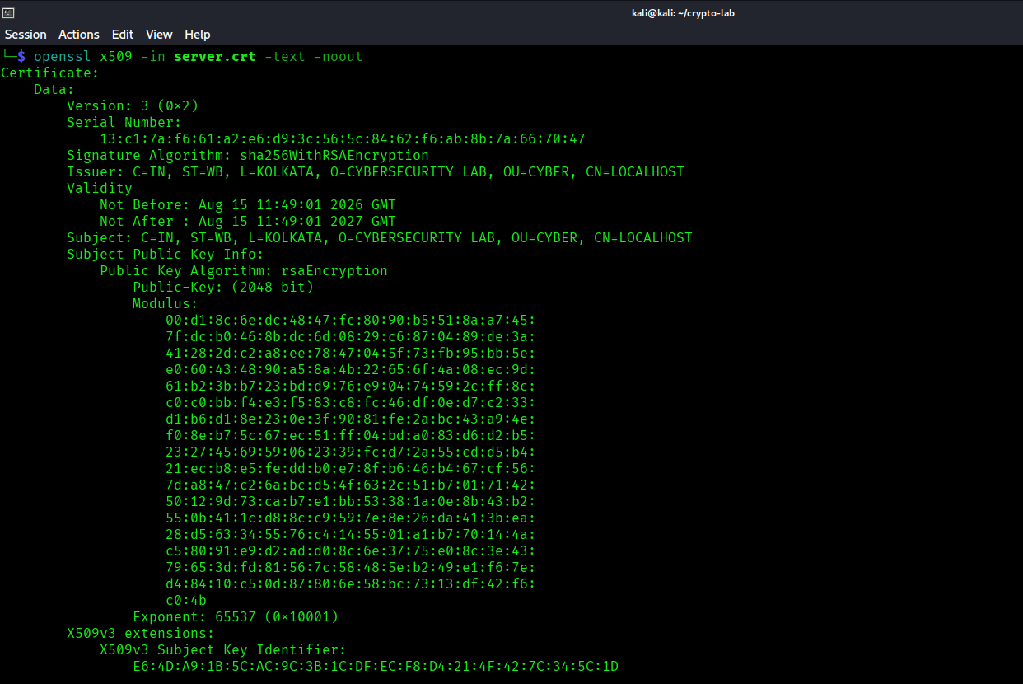
Figure 19. X.509 digital certificate details.

6.5 SSL/TLS

A local TLS test environment was configured using the generated certificate and private key. The exercise demonstrated certificate-based encrypted communication.
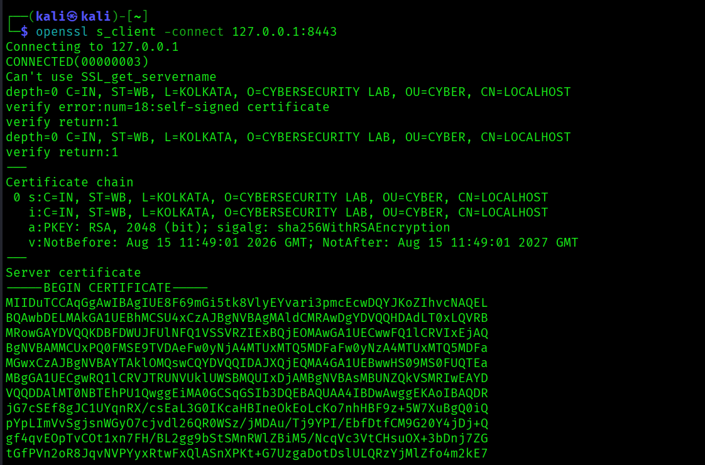
Figure 20. SSL/TLS practical evidence.

7. Tool Familiarization

7.1 Nmap

Nmap was used to identify reachable ports and services on the intentionally vulnerable target in the isolated lab.
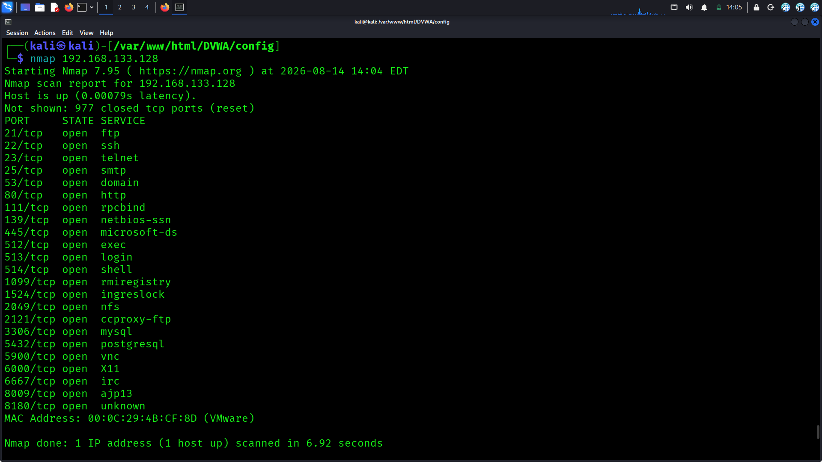
Figure 21. Nmap scan results.

7.2 Wireshark

Wireshark was used to capture and inspect network packets. Both HTTP and ICMP traffic were observed to understand how protocol data appears at packet level.
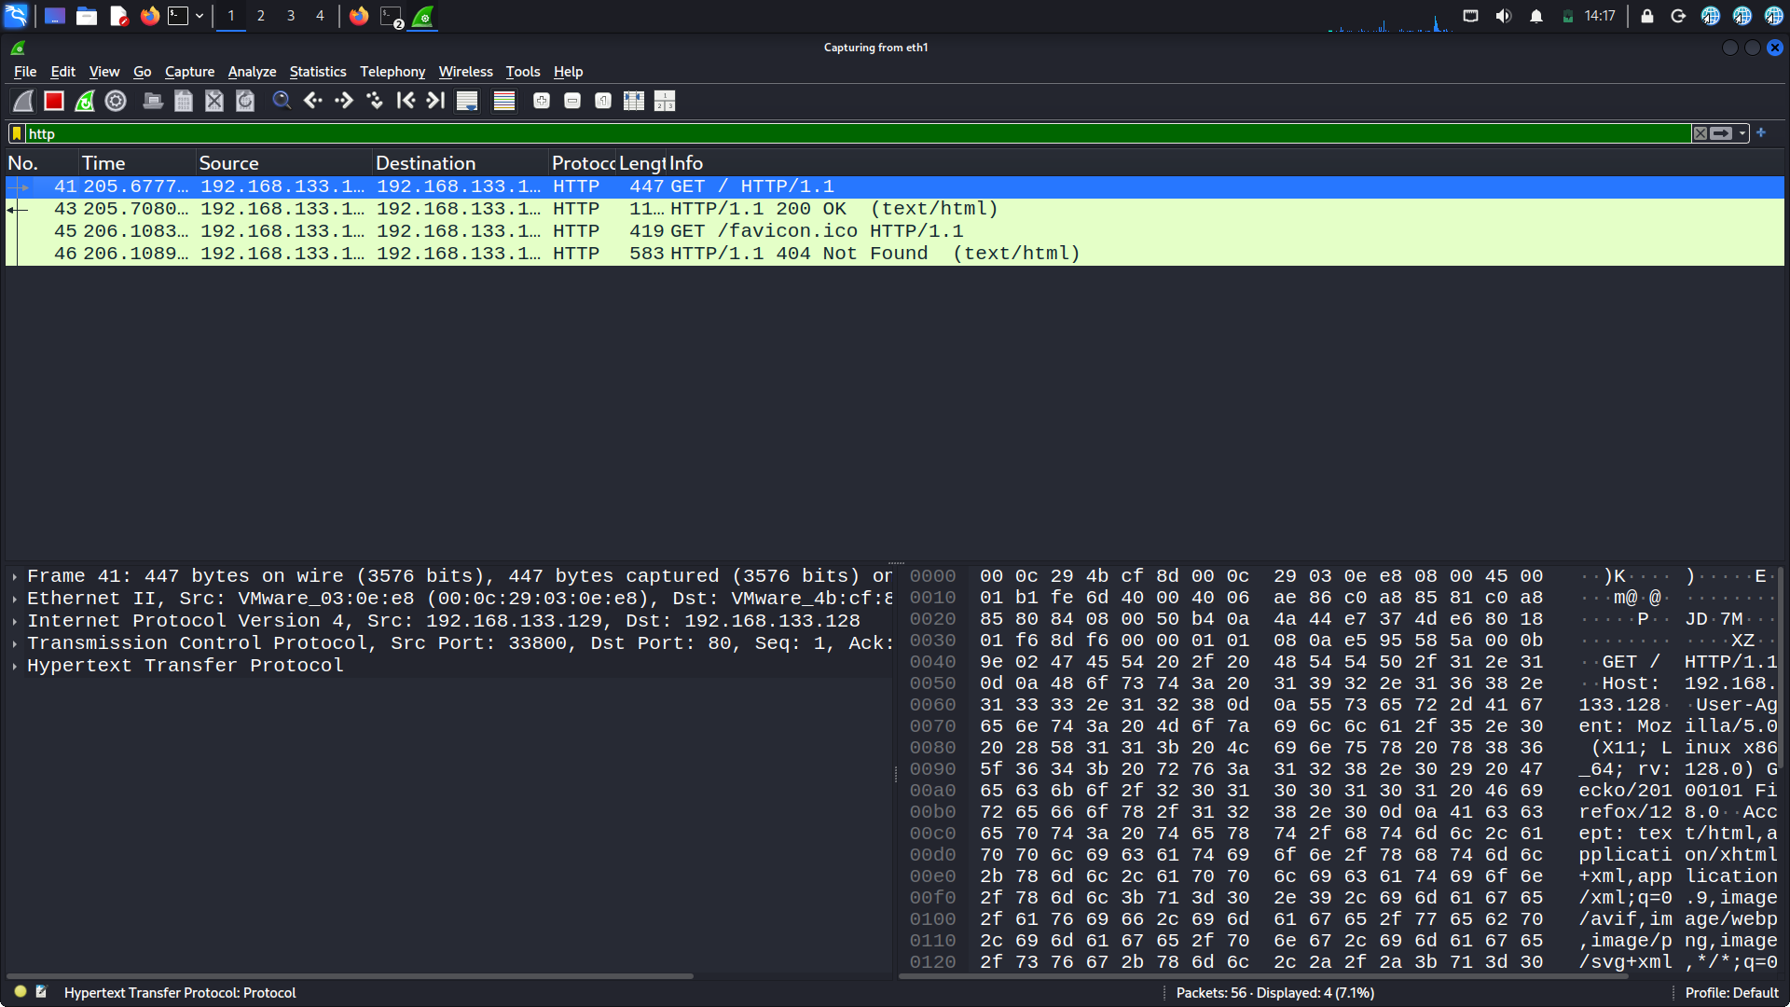
Figure 22. Wireshark HTTP packet capture.
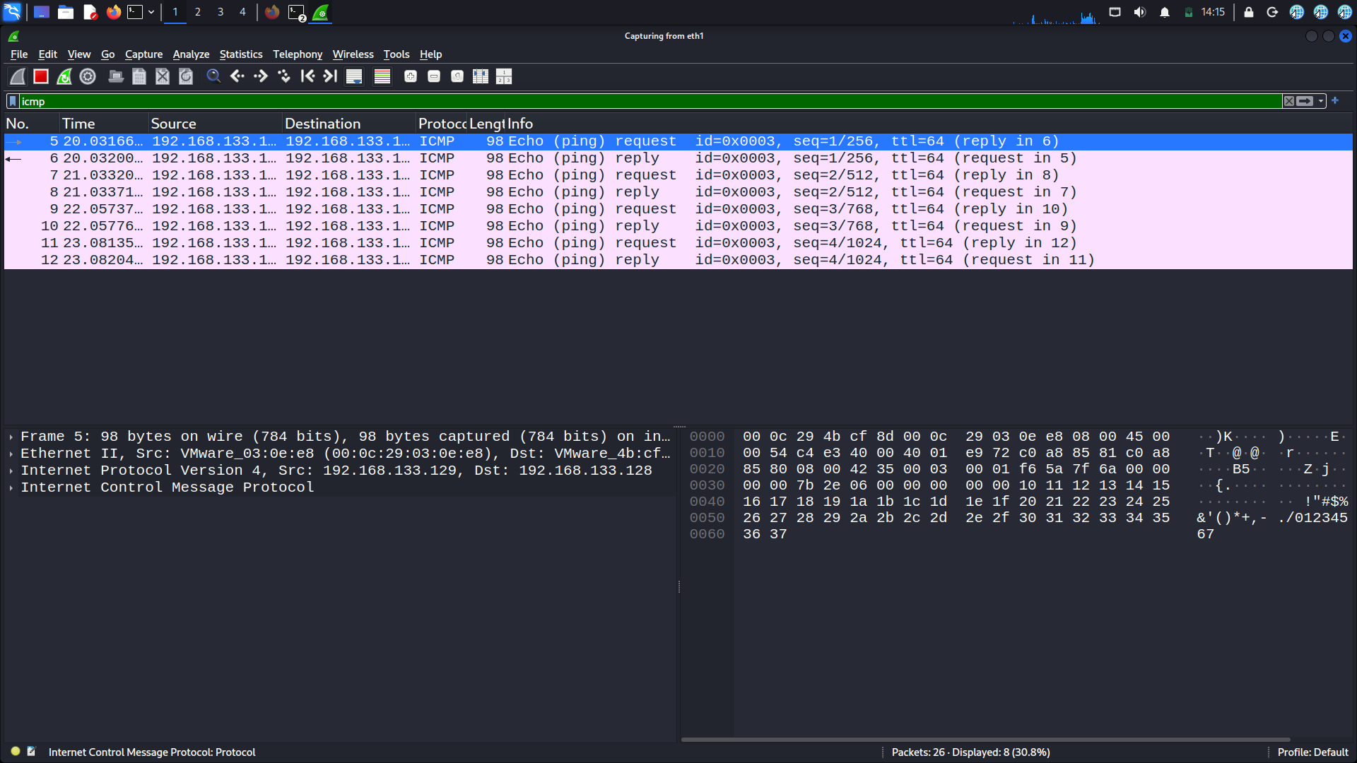
Figure 23. Wireshark ICMP packet capture.

7.3 Burp Suite

Burp Suite was configured as a web proxy and used to observe HTTP requests generated while interacting with the DVWA environment.
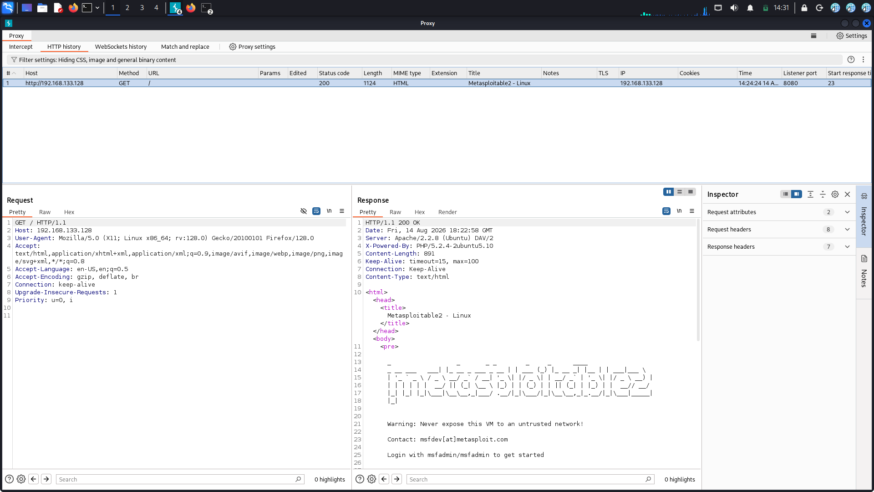
Figure 24. Burp Suite web traffic/proxy evidence.
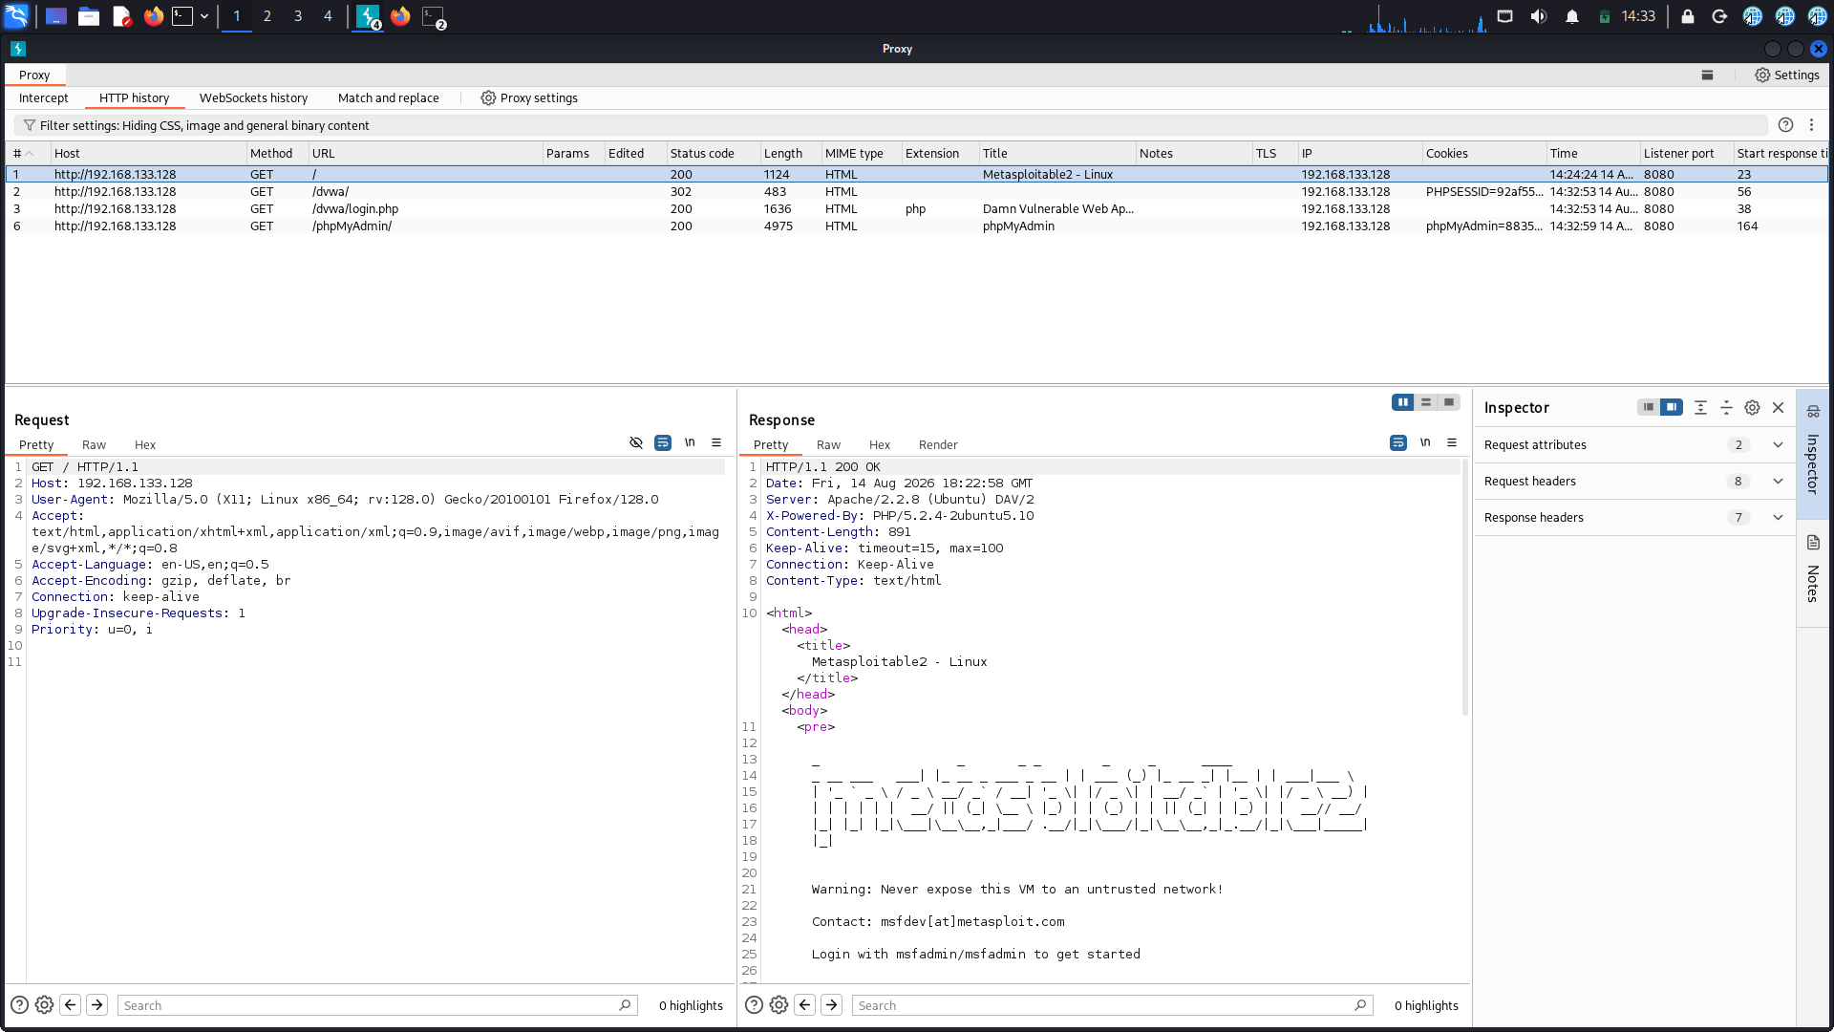
Figure 25. DVWA request/interaction evidence.

7.4 Netcat

Netcat was used for a basic TCP listener/client test, demonstrating simple network connectivity and troubleshooting.
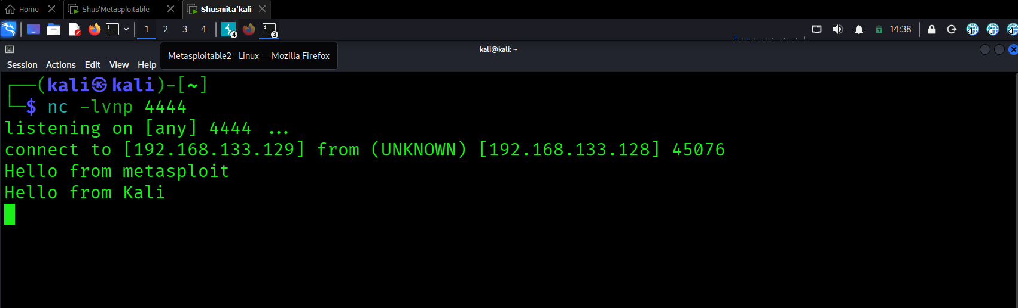
Figure 26. Netcat listener/client test on Kali Linux.
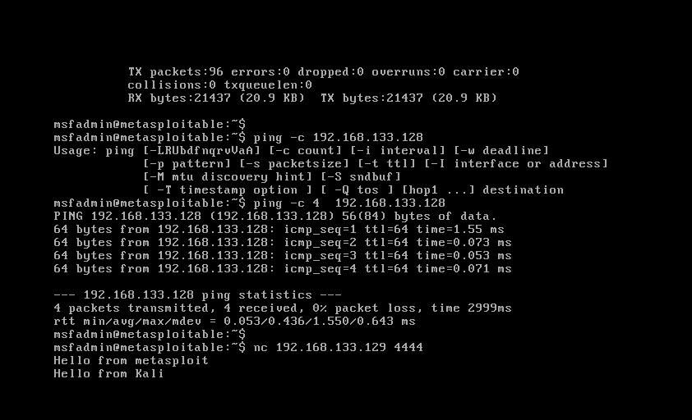
Figure 27. Netcat test from the target-side environment.

8. Observations and Results

- The virtual machines successfully communicated through the isolated Host-only network.
- Kali Linux successfully maintained NAT and Host-only connectivity.
- Apache and DVWA were accessible and operational in the lab.
- Linux navigation, permissions, package management, and networking commands were successfully practiced.
- DNS resolution and HTTP communication were verified.
- OpenSSL exercises demonstrated encryption/decryption, hashing, certificate generation, and TLS concepts.
- Nmap, Wireshark, Burp Suite, and Netcat were successfully used for basic network and web-security analysis.

9. Conclusion

The cybersecurity lab was successfully established as a controlled environment for authorized practical learning. The project covered cybersecurity fundamentals, Linux administration, networking, cryptography, and security-tool familiarization. The combination of an isolated Host-only network, Kali Linux, and intentionally vulnerable targets provides a suitable foundation for further penetration-testing and defensive-security exercises.

10. References

- Kali Linux documentation and manual pages.
- OpenSSL documentation and manual pages.
- Nmap reference documentation.
- Wireshark documentation.
- Burp Suite documentation.
- DVWA project documentation.
- Metasploitable2 lab documentation.

